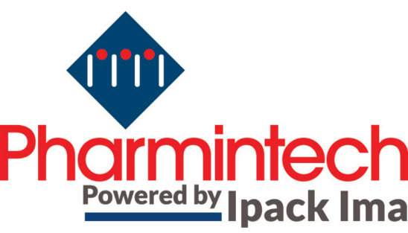

Pharmintech and IPACK-IMA together again in 2025
Renewal of the agreement between Bologna Fiere and Ipack Ima

Milan, 2nd August 2022 - Wide audience success and quality of the technological offer proposed by international companies with the most innovative solutions for the life sciences industries: the last edition of PHARMINTECH, held from 3rd to 6th May 2022 at Fiera Milano, has overcome the expectations of exhibitors and operators and Gruppo Bologna Fiere and Ipack Ima Srl, announce the renewal of the agreement for the next two editions.

Therefore, the fruitful collaboration will re-propose the course of PHARMINTECH within the scope of IPACK-IMA, scheduled in Milan from 27th to 30th May 2025.
Confirmed also the role of Ipack Ima Srl as manager of the organizational secretariat of the event, thanks to the agreement that marked an innovation in the European exhibition scene.

“We are fully satisfied with this "test edition" which has given really interesting results in perspective and we are excited we can give continuity to this synergy.” - states Antonio Bruzzone General Director of BolognaFiere. “PHARMINTECH confirmed itself as a great opportunity of discussion between technology suppliers and operators of the chemical-pharmaceutical world, as well as a hub for innovation in a sector that fits well into the context of IPACK-IMA”.

As a statement of the success, the last edition data: 287 exhibitors, of which 31% foreign from 27 countries, showcased advances technologies in the packaging and processing field for the chemical-pharma sector to an audience of 8.733 specialized operators from 47 foreign countries, up 37% compared to the past edition.

“I thank Bologna Fiere for the trust placed in Ipack Ima with the renewal of this collaboration” – declares Valerio Soli President of Ipack Ima Srl – “thanks to which we can give continuity to an innovative exhibiting project, that collects needs from exhibitors and visitors belonging to adjacent industrial sectors, so able to create synergies and opportunities for the whole industry, in a unique show of international relevance.”

Technological innovation, digitization and sustainability therefore will meet again at IPACK-IMA and PHARMINTECH, scheduled in Fiera Milano from 27th to 30th May 2025, in a unique context dedicated to the manufacturing industry and to specialization and technology transfer.

For infomation: press@ipackima.it

